**The 2025 Annual Linton Soiree**

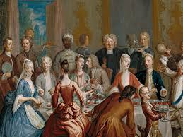

**Wednesday, 14th May Time 7:30 pm**

**Linton The Village Hall**

Join us for the 2025 Annual Linton Soiree! This is a wonderful opportunity to meet your neighbours, enjoy drinks and nibbles, and chat about all that is happening in and around our Parish.

Bernie Cresswell will be your MC for the evening guiding us through the night and a guest speaker may make an appearance.

So, come join us in the village hall for an evening of fun, food, and conversation. We look forward to seeing you there.